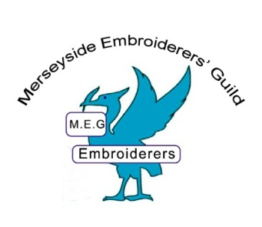

Membership Form 2017 – 2018
Membership  Subscription | H.Q. | Merseyside | Total to pay | Tick
For 18 – 24 years | £13.00 | £8.00 | £21.00
25 years plus | £35.00 | £8.00 | £43.00
Member of another branch | £0 | £8.00 | £8.00

Embroiderers’ Guild H.Q. subscription fees are included in the above rates. We forward this money to H.Q. at Walton-on-Thames. A Regional Levy of £1 is payable for members where Merseyside is their primary branch. The remainder is for branch costs. You will receive your CONTACT magazine from H.Q.
NAME………………………………………….. TITLE………. MEMBERSHIP No………………………
ADDRESS……………………………………………………………………………………………………..POSTCODE……………………… Year you joined the Guild…………………….
TELEPHONE No……………………………………EMAIL………………………………………………
Amount paid……………………cheque/cash Signed………………………………………………….
Date…………………………………………….
If you are a full member of another Branch, please give the name of the Branch-
If you have already joined the Guild through H.Q. you still need to pay £8.00 to join Merseyside Branch. We will need to see either your Life Member’s card or your H.Q. Member’s card before we can accept your Branch fee.
If you are a member of Embroiderers’ Guild H.Q., please give your Membership No……………….
Please make cheques payable to- Merseyside Branch of the Embroiderers’ Guild
Charity Gift Aid Declaration – single donation
In order to Gift Aid your donation you must tick the box below:-
I want to Gift Aid my donation of………. to (name of charity)…………………………………………
I am a UK taxpayer and understand that if I pay less Income Tax and/or Capital Gains Tax in the current tax year than the amount of Gift Aid claimed on all my donations it is my responsibility to pay any difference. Date…………………………..
Title…….Initials………..Surname…………………………………………
Full Home Address……………………………………………………………Postcode…………………………

Applications to be sent to the Membership Secretary Mrs M. Ralston 28 Plemont Road Liverpool
L 13 6RT by 1st September 2017, or paid in person at the August or September meetings at All HALLOWS. Contact- Mal Ralston 01512208240

